**Name: Varad Patil**

**Batch: A2**

**Roll no: 120A2036**

**Experiment 11**

**Aim:** Shell script to delete a line containing a particular word.

**Software:** Ubuntu

**Procedure:**

* Using command #gedit create a file with .sh extension name it sk.sh
* Enter the any paragraph in the file. For Ex:-

Once upon atime,

There was a prey.

He was 11 years old.

He used to visit Jungle only.

one day he saw tiger infront of him.

He stood strong and prayed god.

The tiger went away looking at his prayers.

* Now create a new file with sh extension name it delete.sh using command gedit filename.sh.
* In this file we enter the given shellscript to delete a line containing particular

word.

echo enter filename

read file

echo enter word

read word

echo

echo file before removing $word:

cat $file

grep -v -i $word $file>test

mv test $file

echo file after removing $word:

cat $file

* Use commands #chmod +x filename.sh to give execution rights to both files.
* Then ./filename.sh to launch the delete.sh file.
* Then enter the filename with sh extension from which you want to delete a line.
* Enter the word to delete the line containing that particular word.

**Output:**

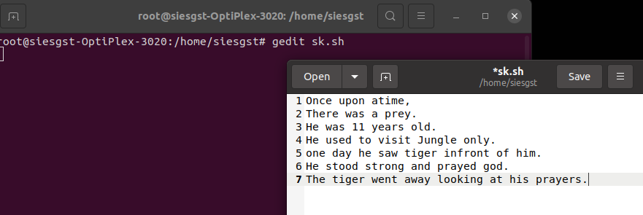

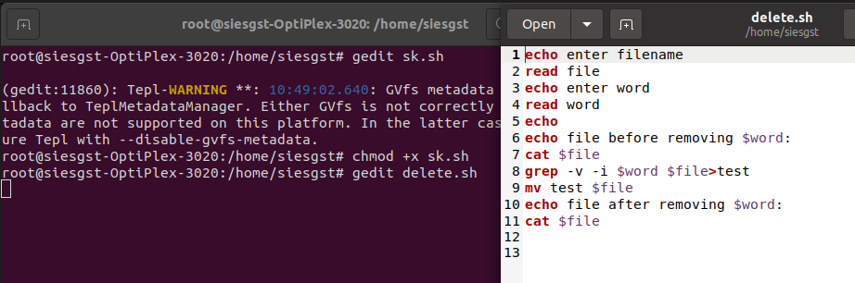

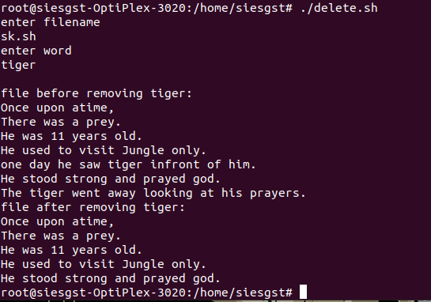

**Conculsion:**

The Shell script to delete a line containing a particular word was performed successfully.